VPC Endpoint :

1.Create a vpc

2.Create two subnets

3.Create IGW attach to your vpc

4.along with vpc one route table is created ..Create another route table

5.Route table associate with pub and pvt Subnets

6. pub route table attach to the IGW

7.pub-subnet assing the auto assign public ip

Create two aws ec2 instance

1 for pub-ec2 instance

2. for pvt ec2- instance

**Go to IAM**

Create a user ex: testuser

Provide s3 full accesss

Go to instance

Aws configure

Enter access key and secret key and region and text or json

Aws s3 ls

Pub-ec2 instance aws s3 ls command works

Pvt ec2 instacne aws s3 ls command not works

Create VPC Endpoint :

With out having internet connectivity you can access aws resouces using VPC end point .

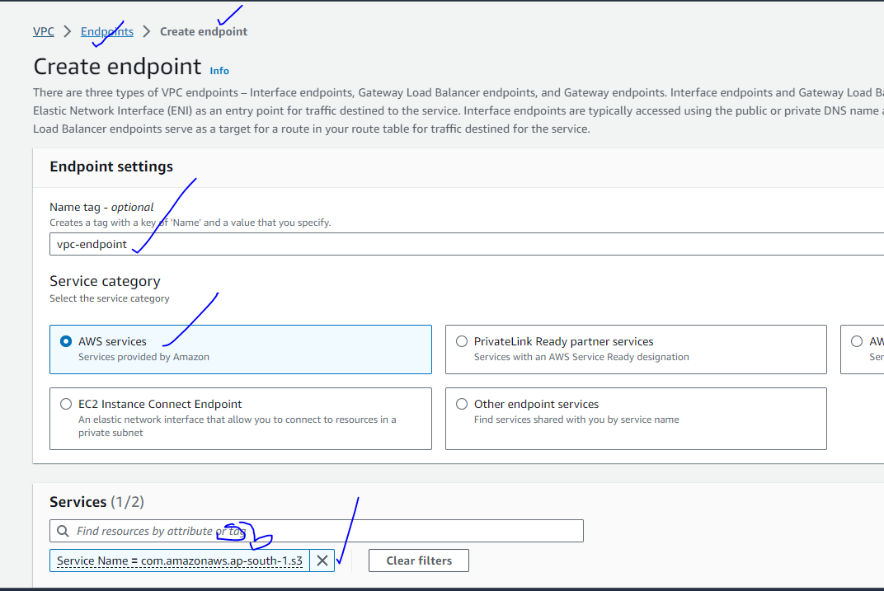

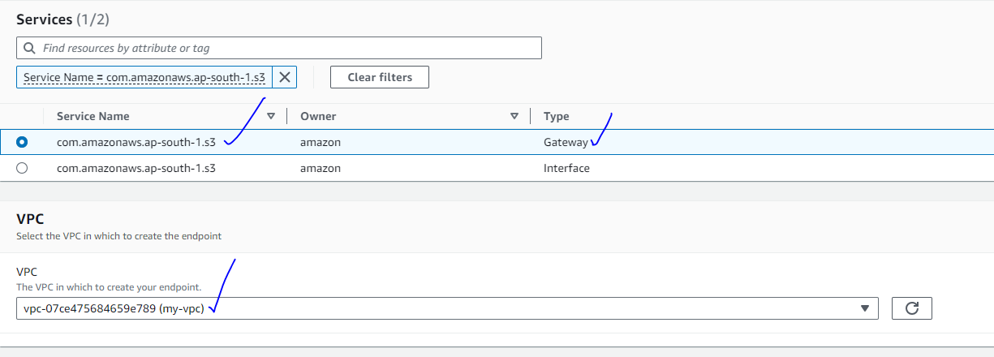

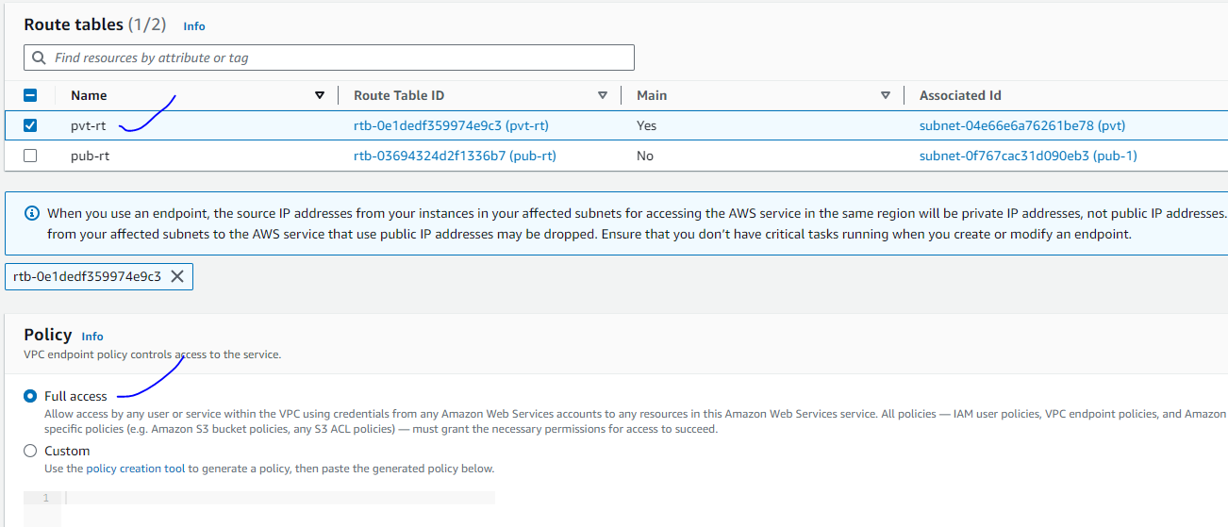

Without having internet access you can access aws resource or service using vpc endpoint